**SUPPLEMENTAL MATERIAL**

**Table S1.** Mean (SE) values of segmented power-law model parameters estimated in rigid nasal pathway casts of infants with a superimposed breathing of 0.75 Hz and individually calculated tidal volumes. Data show parameters calculated for the expiratory limb. V’bp: flow at the breakpoint, k1: steepness of the first segment (when V’≤ V’bp); k2: steepness of the second segment (when V’>V’bp).

|  |  |  |  |  |  |
| --- | --- | --- | --- | --- | --- |
| **ID** | **ln V’bp**  **(SE)** | **intercept**  **(SE)** | **k1**  **(SE)** | **k2**  **(SE)** | **adjusted r2** |
| **cast 001** | 3.25  (0.017) | 2.19  (0.03) | 0.073  (0.013) | 1.169  (0.031) | 0.990 |
| **cast 003** | 3.57  (0.023) | 1.81  (0.03) | 0.022  (0.010) | 0.976  (0.029) | 0.984 |
| **cast 005** | 3.87  (0.024) | 0.41  (0.03) | 0.021  (0.009) | 0.843  (0.025) | 0.986 |
| **cast 006** | 3.78  (0.018) | 2.92  (0.05) | 0.024  (0.015) | 1.506  (0.045) | 0.983 |
| **cast 007** | 3.55  (0.034) | 0.62  (0.03) | 0.039  (0.011) | 0.779  (0.034) | 0.974 |
| **cast 008** | 3.93  (0.023) | 2.16  (0.03) | 0.005  (0.008) | 0.930  (0.025) | 0.985 |
| **cast 009** | 4.21  (0.027) | 1.82  (0.07) | 0.132  (0.020) | 1.160  (0.052) | 0.976 |
| **cast 010** | 4.11  (0.021) | 0.74  (0.03) | 0.036  (0.010) | 1.060  (0.034) | 0.983 |
| **cast 012** | 4.15  (0.031) | 1.75  (0.08) | 0.018  (0.022) | 1.064  (0.050) | 0.969 |
| **cast 014** | 3.50  (0.021) | 1.27  (0.03) | 0.042  (0.010) | 0.911  (0.024) | 0.989 |
| **cast 015** | 4.19  (0.026) | 2.12  (0.07) | -0.032  (0.020) | 1.042  (0.037) | 0.979 |
| **cast 016** | 3.34  (0.022) | 1.10  (0.03) | 0.075  (0.012) | 1.026  (0.029) | 0.988 |
| **cast 017** | 4.30  (0.019) | 2.16  (0.06) | 0.012  (0.015) | 1.215  (0.037) | 0.985 |
| **cast 018** | 3.82  (0.02) | 1.80  (0.05) | 0.031  (0.016) | 0.935  (0.024) | 0.991 |
| **cast 019** | 3.96  (0.019) | 0.83  (0.03) | 0.062  (0.010) | 0.874  (0.026) | 0.989 |
| **cast 021** | 4.02  (0.019) | 1.70  (0.03) | 0.045  (0.011) | 1.140  (0.032) | 0.986 |
| **cast 022** | 4.35  (0.023) | 2.04  (0.09) | 0.059  (0.024) | 1.306  (0.051) | 0.977 |
| **cast 025** | 4.20  (0.020) | 1.30  (0.03) | 0.055  (0.010) | 1.058  (0.033) | 0.985 |
| **cast 026** | 3.88  (0.02) | 2.73  (0.03) | 0.033  (0.010) | 1.223  (0.036) | 0.984 |
| **cast 027** | 3.84  (0.022) | 0.20  (0.04) | 0.044  (0.013) | 0.897  (0.027) | 0.987 |
| **cast 028** | 3.92  (0.025) | 0.84  (0.05) | 0.047  (0.014) | 0.910  (0.029) | 0.986 |
| **cast 030** | 3.92  (0.026) | 2.65  (0.05) | 0.007  (0.016) | 0.944  (0.034) | 0.979 |
| **cast 032** | 3.69  (0.019) | 1.09  (0.02) | 0.033  (0.007) | 0.892  (0.022) | 0.991 |
| **cast_034** | 4.19  (0.03) | 0.75  (0.04) | 0.028  (0.012) | 1.052  (0.044) | 0.974 |
| **cast_035** | 3.39  (0.022) | 0.29  (0.02) | 0.043  (0.009) | 0.888  (0.026) | 0.988 |
| **cast 039** | 3.88  (0.026) | 1.88  (0.06) | 0.017  (0.020) | 1.160  (0.041) | 0.980 |
| **cast 040** | 3.87  (0.026) | 0.41  (0.03) | 0.014  (0.009) | 0.889  (0.032) | 0.979 |
| **cast 041** | 3.90  (0.033) | -0.02  (0.04) | 0.040  (0.015) | 0.856  (0.036) | 0.975 |
| **cast 042** | 4.40  (0.026) | 1.38  (0.06) | 0.086  (0.017) | 1.055  (0.043) | 0.979 |
| **cast 043** | 4.48  (0.019) | 1.10  (0.04) | 0.080  (0.012) | 0.981  (0.028) | 0.989 |
| **cast 051** | 4.30  (0.045) | 0.54  (0.06) | 0.031  (0.018) | 0.788  (0.044) | 0.951 |
| **cast 175** | 4.03  (0.024) | 0.97  (0.06) | 0.053  (0.017) | 0.897  (0.029) | 0.988 |
| **cast 220** | 4.35  (0.021) | 2.20  (0.06) | 0.009  (0.016) | 1.348  (0.043) | 0.981 |
| **cast 300** | 4.30  (0.024) | 1.09  (0.04) | 0.092  (0.012) | 0.968  (0.034) | 0.985 |
| **cast 398** | 4.68  (0.021) | 0.66  (0.03) | 0.016  (0.008) | 0.855  (0.027) | 0.982 |
| **cast 444** | 4.24  (0.022) | 0.19  (0.05) | 0.061  (0.013) | 0.976  (0.033) | 0.985 |
| **cast 457** | 3.25  (0.017) | 2.13  (0.03) | 0.066  (0.011) | 0.993  (0.028) | 0.990 |
| **cast 609** | 4.22  (0.019) | 2.34  (0.03) | 0.035  (0.008) | 1.056  (0.034) | 0.985 |
| **cast 619** | 4.11  (0.019) | 2.49  (0.06) | 0.021  (0.017) | 1.261  (0.040) | 0.985 |
| **cast 651** | 4.42  (0.023) | 1.32  (0.07) | 0.139  (0.019) | 1.005  (0.039) | 0.985 |
| **cast 832** | 4.04  (0.029) | 0.73  (0.04) | 0.057  (0.013) | 0.875  (0.038) | 0.977 |
| **cast 955** | 4.37  (0.021) | 1.69  (0.05) | 0.021  (0.014) | 1.015  (0.033) | 0.984 |
| **cast 968** | 4.38  (0.020) | 1.86  (0.04) | 0.050  (0.011) | 1.354  (0.047) | 0.981 |
| **cast 7418** | 4.23  (0.028) | 1.89  (0.10) | 0.053  (0.028) | 1.171  (0.052) | 0.977 |
| **cast 9025** | 4.50  (0.020) | 1.57  (0.07) | 0.117  (0.019) | 1.244  (0.042) | 0.986 |

**Table S2.** The characteristics of newborns involved in oscillatory mechanics measurements. PVN: per vias naturalis, SC: Caesarean section, M: male, F: female.

|  |  |  |  |  |  |  |
| --- | --- | --- | --- | --- | --- | --- |
| **ID** | **Measurement after delivery (hours)** | **Length (cm)** | **Weight (g)** | **Gestational age (week)** | **Delivery** | **Sex** |
| **#1** | 3 | 45 | 2820 | 38 | PVN | M |
| **#2** | 8 | 47 | 2870 | 39 | PVN | F |
| **#3** | 56 | 46 | 2400 | 39 | PVN | F |
| **#4** | 62 | 53 | 3900 | 39 | PVN | F |
| **#5** | 39 | 48 | 2760 | 37 | SC | F |
| **#6** | 42 | 50 | 3120 | 41 | SC | M |
| **#7** | 30 | 50 | 3380 | 38-5 | SC | F |
| **#8** | 34 | 50 | 2650 | 39-2 | PVN | M |
| **#9** | 31 | 47 | 2800 | 39-2 | SC | F |
| **#10** | 26 | 52 | 3130 | 39-5 | SC | M |
| **#11** | 91 | 47 | 2340 | 36-2 | SC | F |
| **#12** | 58 | 48 | 3190 | 38 | PVN | F |
| **#13** | 40 | 47 | 2680 | 40-6 | PVN | F |
| **#14** | 75 | 52 | 3460 | 40 | SC | M |
| **#15** | 25 | 49 | 3070 | 39 | SC | F |

**Table S3.** Model parameters estimated in newborns (SE: standard error). V’bp: flow at the breakpoint, k1: steepness of the first segment (when V’≤ V’bp); k2: steepness of the second segment (when V’>V’bp).

|  |  |  |  |  |  |
| --- | --- | --- | --- | --- | --- |
| **ID** | **ln V’bp**  **(SE)** | **intercept (SE)** | **k1**  **(SE)** | **k2**  **(SE)** | **adjusted r2** |
|  |  |  |  |  |  |
| **#1** | 3.71  (0.052) | 3.52  (0.07) | 0.104  (0.023) | 0.788  (0.053) | 0.93 |
| **#2** | 3.87  (0.082) | 3.43  (0.05) | 0.022  (0.016) | 0.450  (0.043) | 0.86 |
| **#3** | 3.18  (0.129) | 4.04  (0.07) | -0.007  (0.028) | 0.443  (0.047) | 0.69 |
| **#4** | 4.11  (0.14) | 3.72  (0.20) | -0.016  (0.063) | 0.775  (0.127) | 0.72 |
| **#5** | 3.63  (0.056) | 3.52  (0.03) | 0.013  (0.011) | 0.446  (0.034) | 0.84 |
| **#6** | 4.07  (0.126) | 3.67  (0.07) | 0.000  (0.024) | 0.506  (0.075) | 0.75 |
| **#7** | 3.60  (0.071) | 3.96  (0.05) | 0.027  (0.019) | 0.617  (0.047) | 0.87 |
| **#8** | 3.91  (0.074) | 2.70  (0.08) | 0.076  (0.024) | 0.393  (0.058) | 0.91 |
| **#9** | 3.37  (0.070) | 3.72  (0.07) | 0.018  (0.028) | 0.681  (0.054) | 0.87 |
| **#10** | 3.98  (0.052) | 3.88  (0.06) | 0.054  (0.018) | 0.728  (0.056) | 0.92 |
| **#11** | 3.37  (0.13) | 4.88  (0.29) | -0.174  (0.104) | 0.746  (0.123) | 0.63 |
| **#12** | 3.94  (0.155) | 4.47  (0.10) | 0.019  (0.031) | 0.561  (0.121) | 0.62 |
| **#13** | 3.66  (0.148) | 3.53  (0.11) | 0.073  (0.034) | 0.385  (0.074) | 0.80 |
| **#14** | 3.79  (0.063) | 3.06  (0.08) | 0.026  (0.024) | 0.644  (0.056) | 0.88 |
| **#15** | 4.22  (0.095) | 3.85  (0.09) | 0.038  (0.027) | 0.793  (0.167) | 0.66 |

**Table S4.** Indication for CT examination.

|  |  |  |
| --- | --- | --- |
| **Subject #** | **Indication** | **Radionology Report** |
| 0001 | Meningitis | Normal CT |
| 0002 | Seizure | Normal CT |
| 0003 | Meningitis | Normal CT |
| 0005 | Rule out brain hemorrhage | Normal CT |
| 0006 | Rule out brain hemorrhage | Normal CT |
| 0007 | Head Trauma | Normal CT |
| 0008 | Rule out brain hemorrhage | Normal CT |
| 0009 | Rule out brain tumor | Normal CT |
| 0010 | Seizure | Normal CT |
| 0012 | Fever of unknown origin | Normal CT |
| 0014 | Rule out brain hemorrhage | Normal CT |
| 0015 | Seizure | Normal CT |
| 0016 | Rule out brain tumor | Frontal ischemic lesion |
| 0017 | Head Trauma | Normal CT |
| 0018 | Rule out brain tumor | Normal CT |
| 0019 | Head Trauma | Meningial Hemorrhage |
| 0021 | Rule out brain abcess | Normal CT |
| 0022 | Rule out brain tumor | Normal CT |
| 0025 | Seizure | Normal CT |
| 0026 | Hydrocephalus | NA |
| 0027 | NA | NA |
| 0028 | Rule out brain hemorrhage | Normal CT |
| 0030 | Rule out brain tumor | Subcutaneous parietal hematoma |
| 0032 | Seizure | Normal CT |
| 0034 | Rule out brain hemorrhage | Normal CT |
| 0035 | Seizure | Normal CT |
| 0039 | Epidural hematoma | Post-surgical epidural thickenning |
| 0040 | Seizure | Normal CT |
| 0041 | Rule out craniostenosis | Normal CT |
| 0042 | NA | NA |
| 0043 | NA | NA |
| 0051 | Rule out brain hemorrhage | NA |
| 0175 | NA | NA |
| 0220 | NA | NA |
| 0300 | NA | NA |
| 0398 | Cervical adenopathy | NA |
| 0444 | Head Trauma | NA |
| 0457 | NA | NA |
| 0609 | NA | NA |
| 0619 | NA | NA |
| 0651 | Abnormal gait | NA |
| 7418 | NA | NA |
| 0832 | NA | NA |
| 9025 | Head Trauma | NA |
| 0955 | Head Trauma | NA |
| 0968 | Head Trauma | NA |

**Figure S1.** Example of fitted ellipsoid to the segmented nasal airway passages, using the 3D Imagej plugin (https://github.com/mcib3d). Green dotted line: major (second) semi-axis; black dotted line: minor (first) semi-axis.

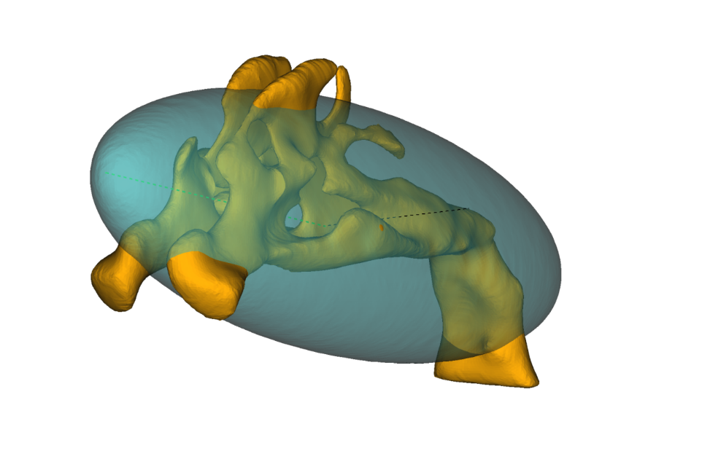

**Figure S2.** Nasal resistance (Rn) versus volume acceleration (V”) in randomly selected upper airway casts. Different colours indicate different respiratory rate and/or tidal volume (VT) of simulated breathing pattern. Solid line is the linear regression fitted to end-expiratory point of resistance (ReE) and V” (V”eE), while dotted line is fitted to end-inspiratory points (ReI and V”eI). The intercept of the linear regressions is a close estimate of the lowest oscillatory R (R0) measured at baseline conditions.

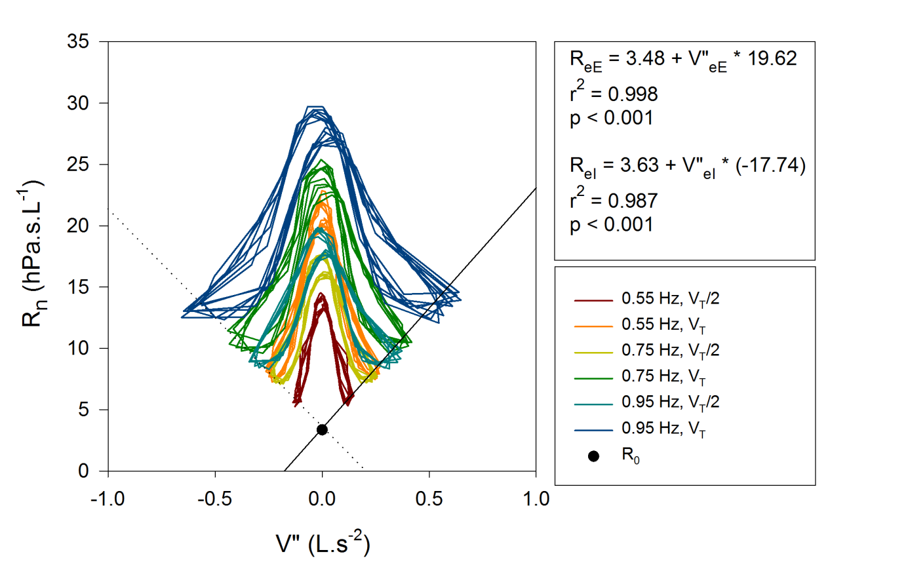

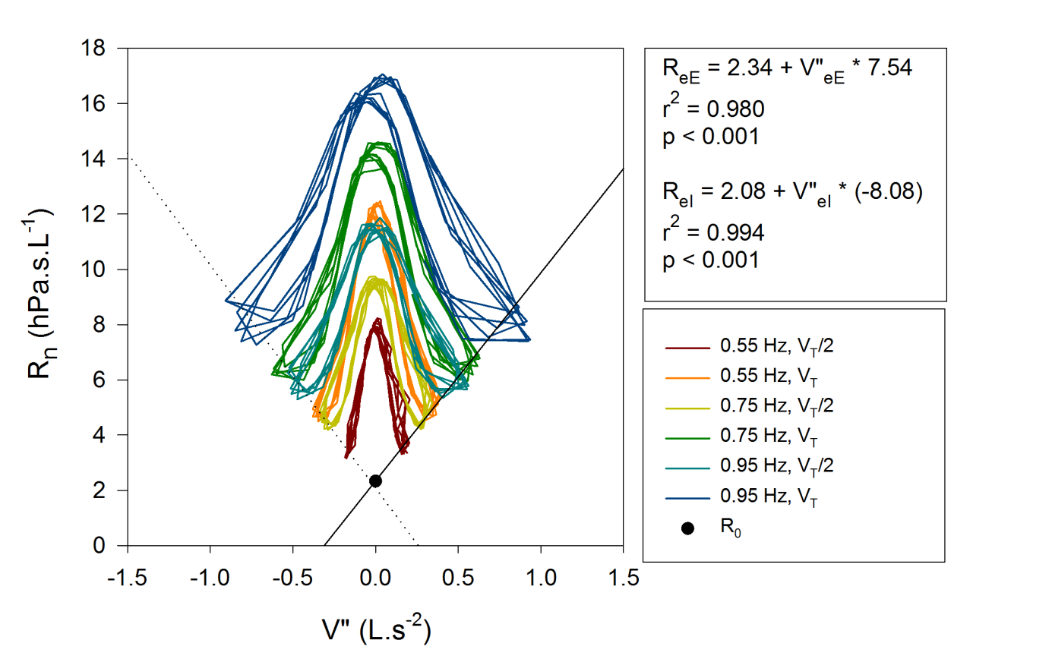

Figure S2 continued

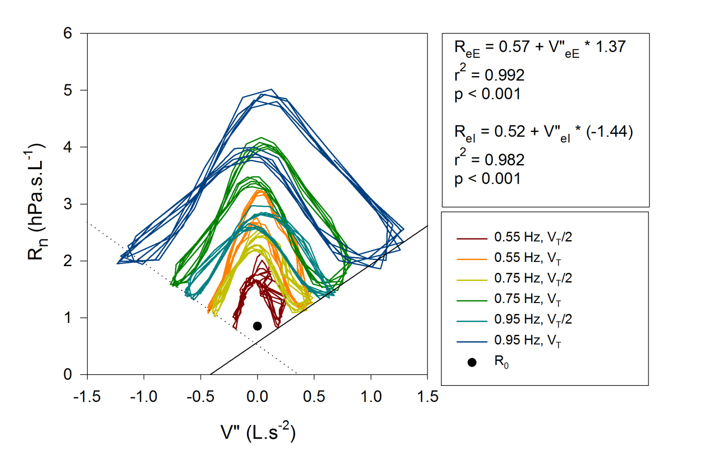

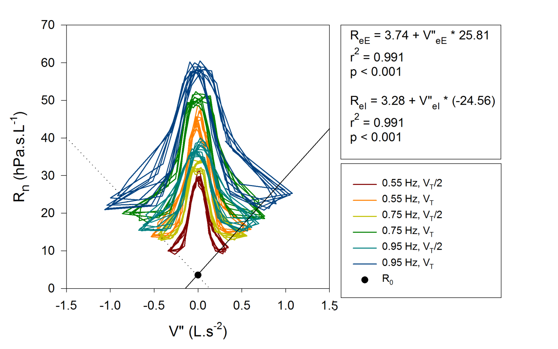

Figure S2 continued

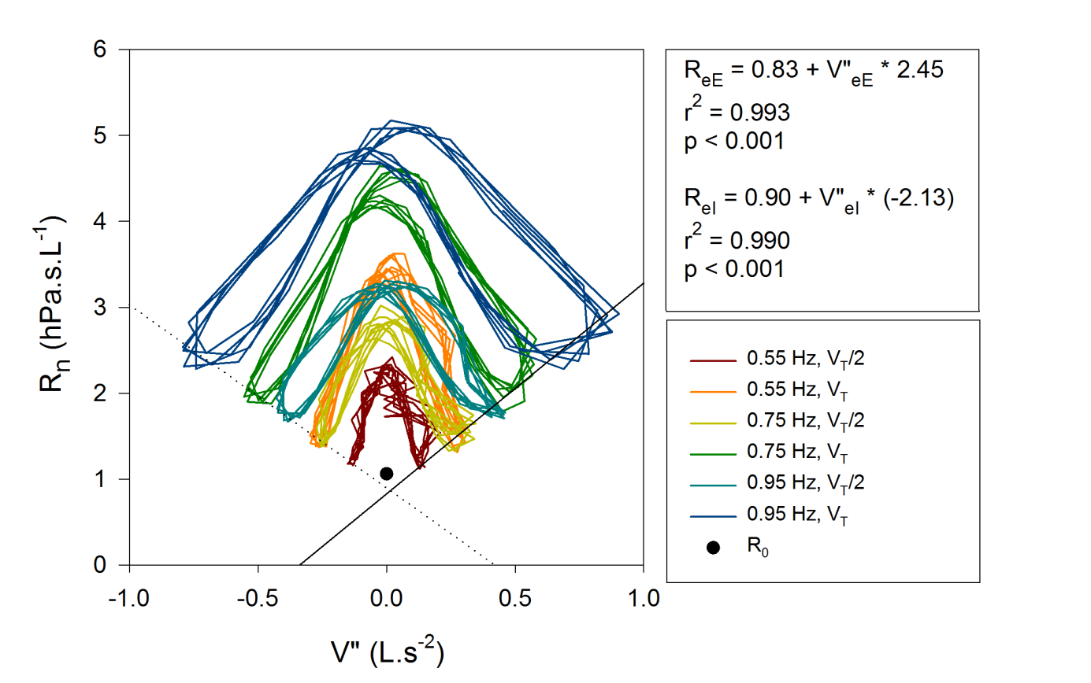

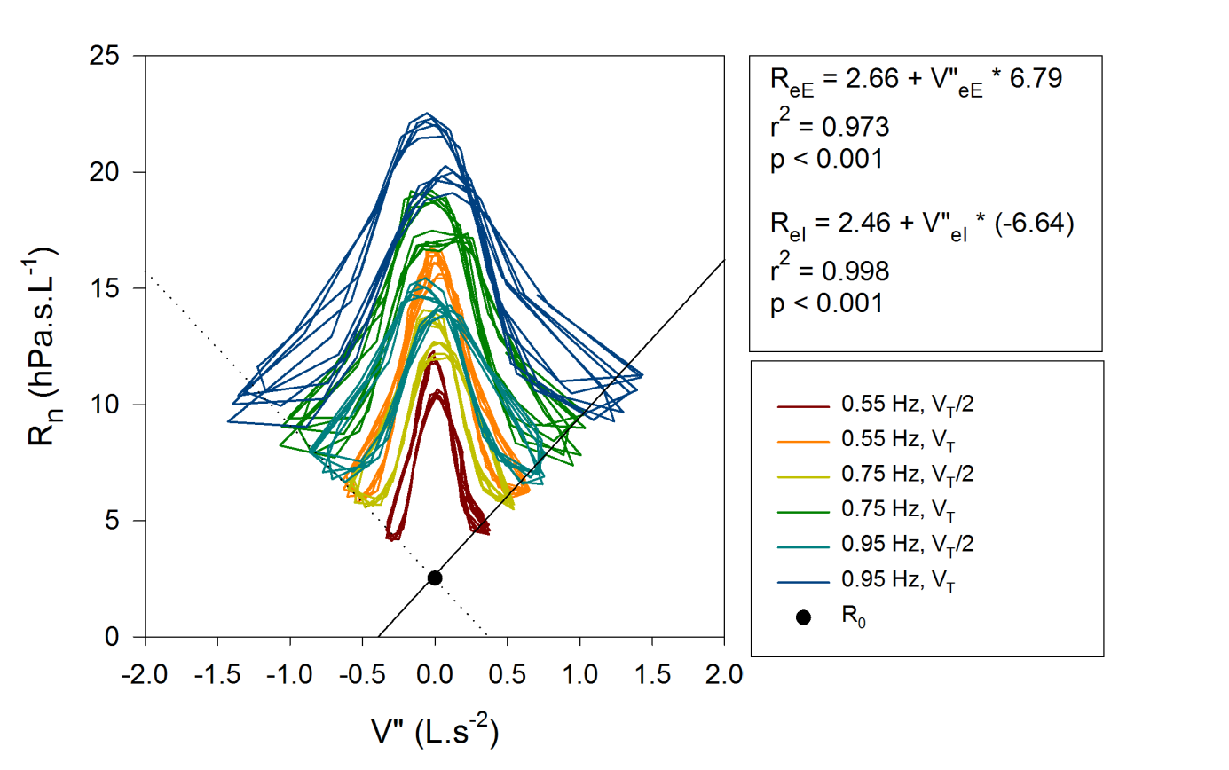

Figure S2 continued

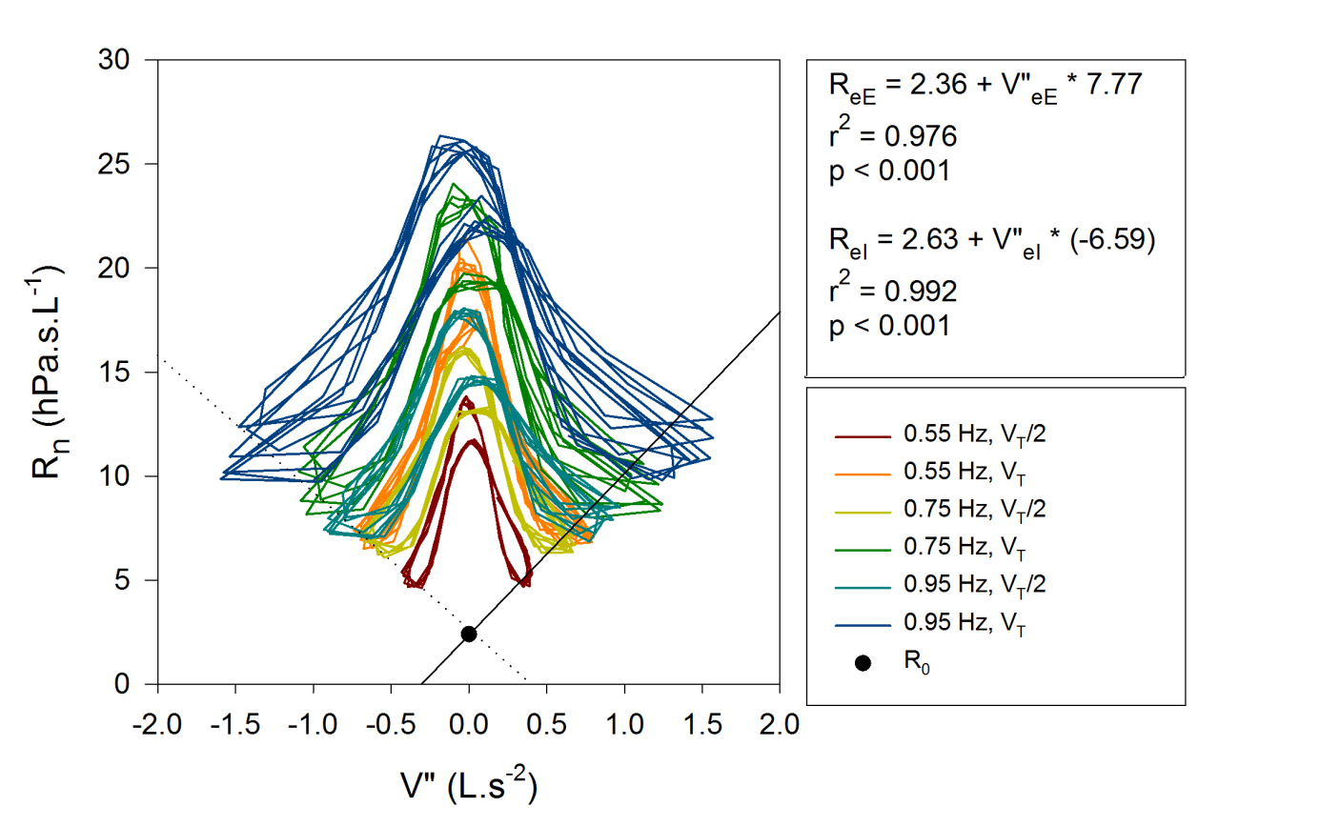

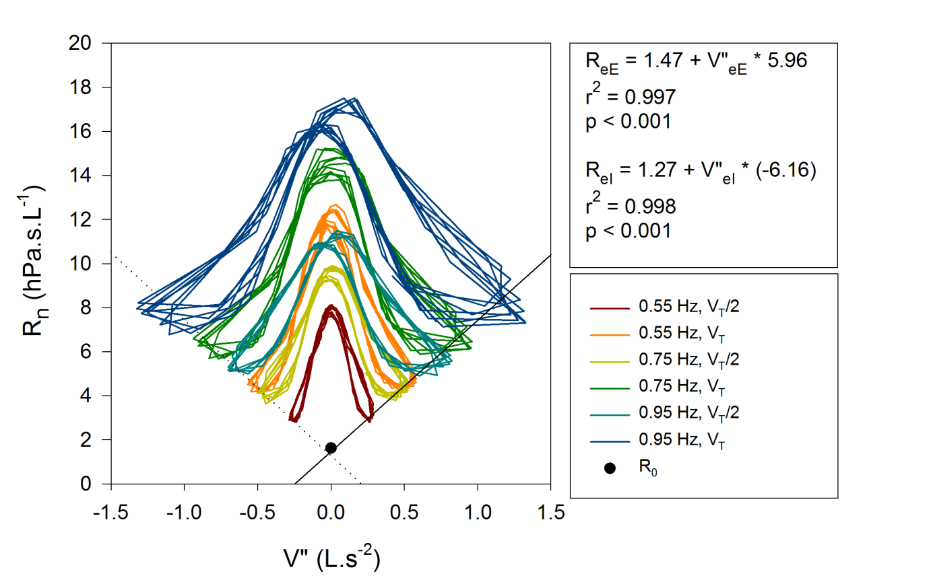

**Figure S3.** Respiratory system resistance (Rrs) vs flow (V’) graphs of newborns - in vivo measurement with segmented model. Only expiratory limb is visualised. Note the logarithmic scale.

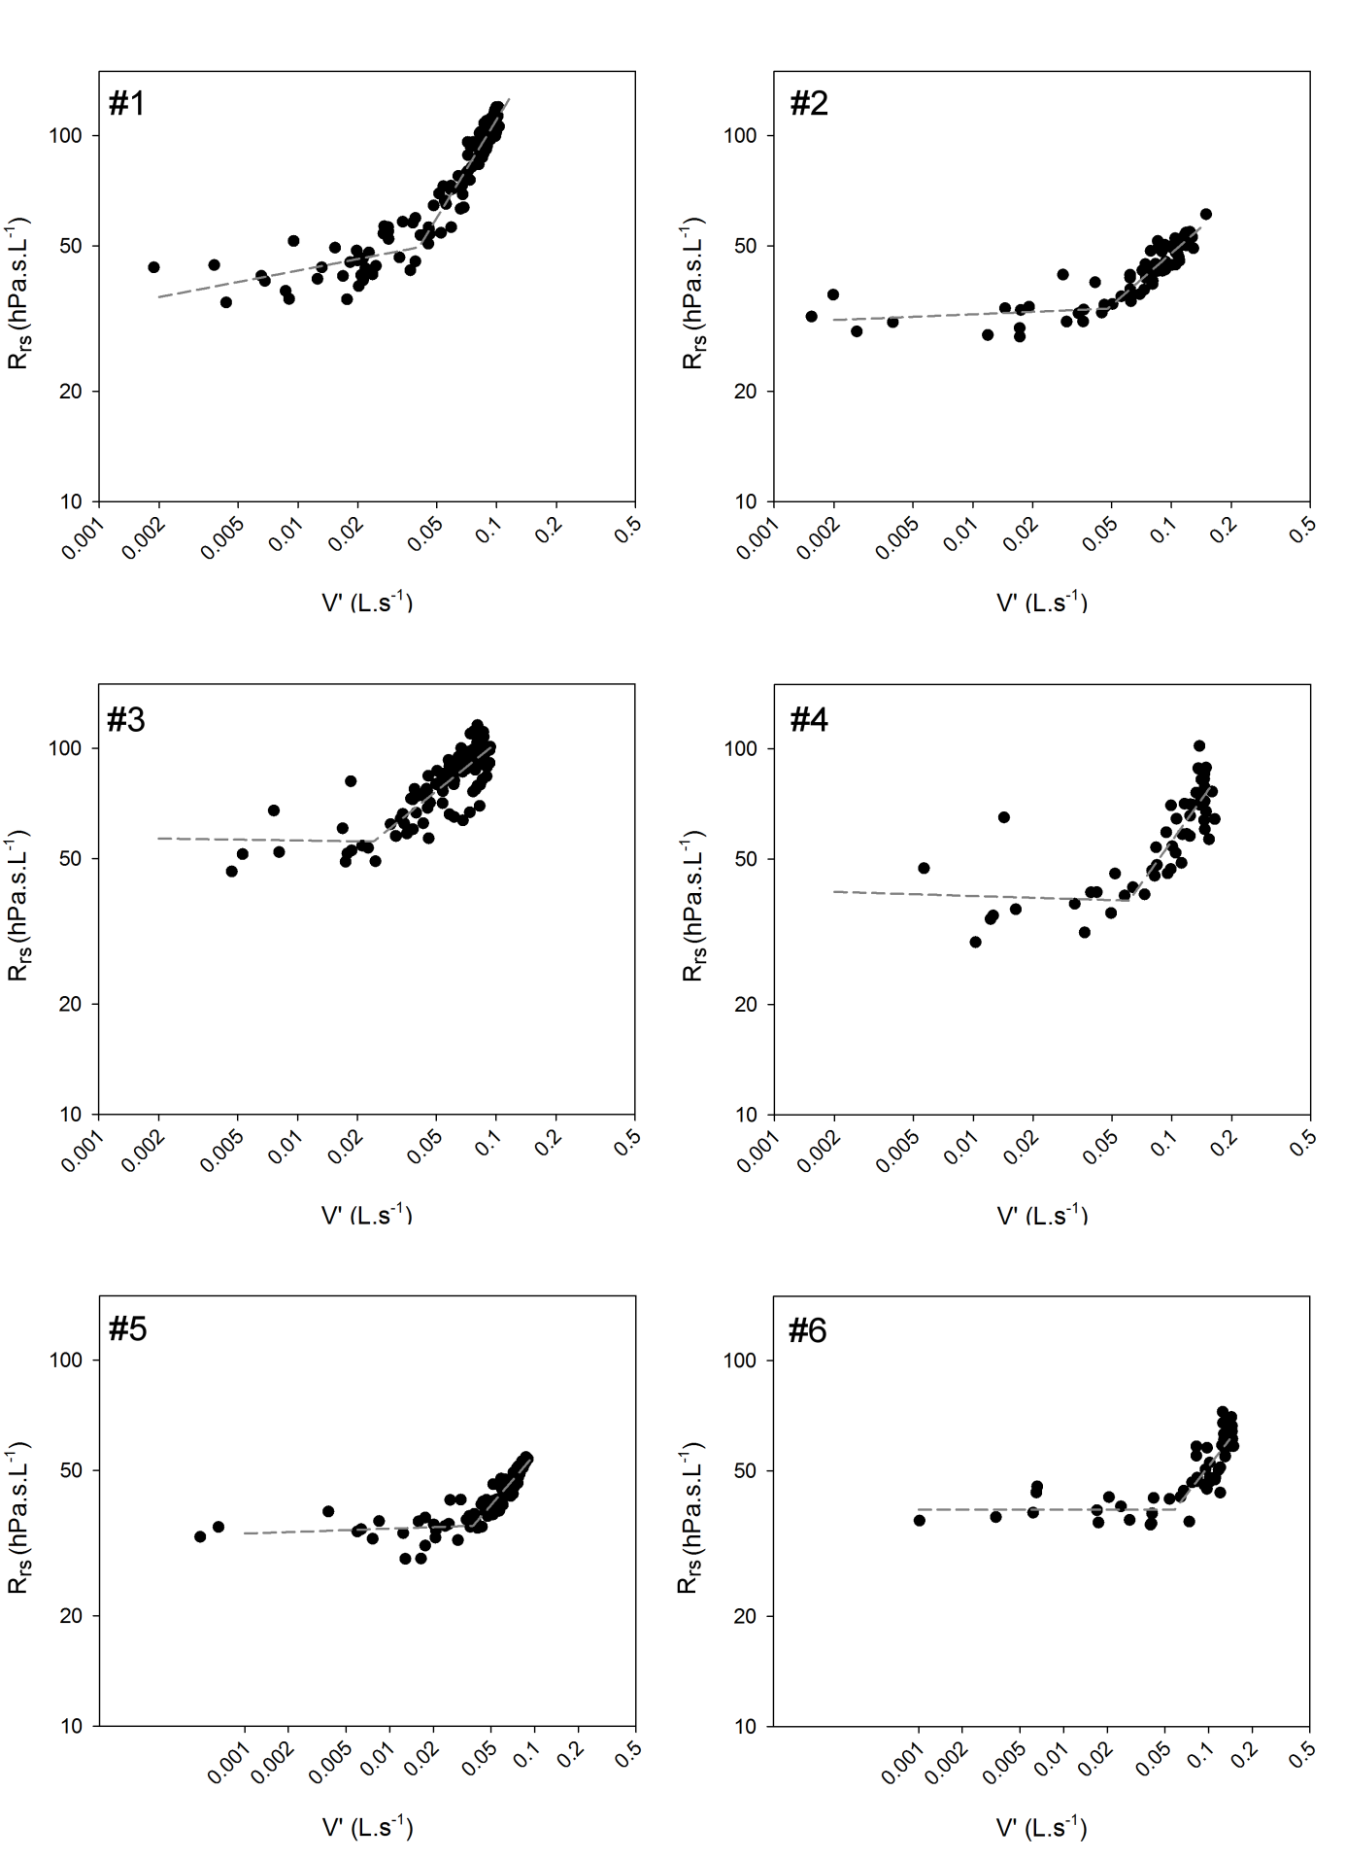

Figure S3 Continued

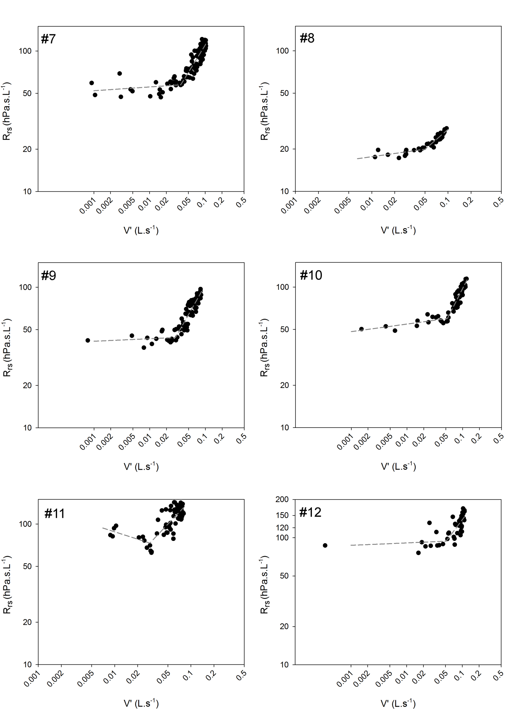

Figure S3 Continued

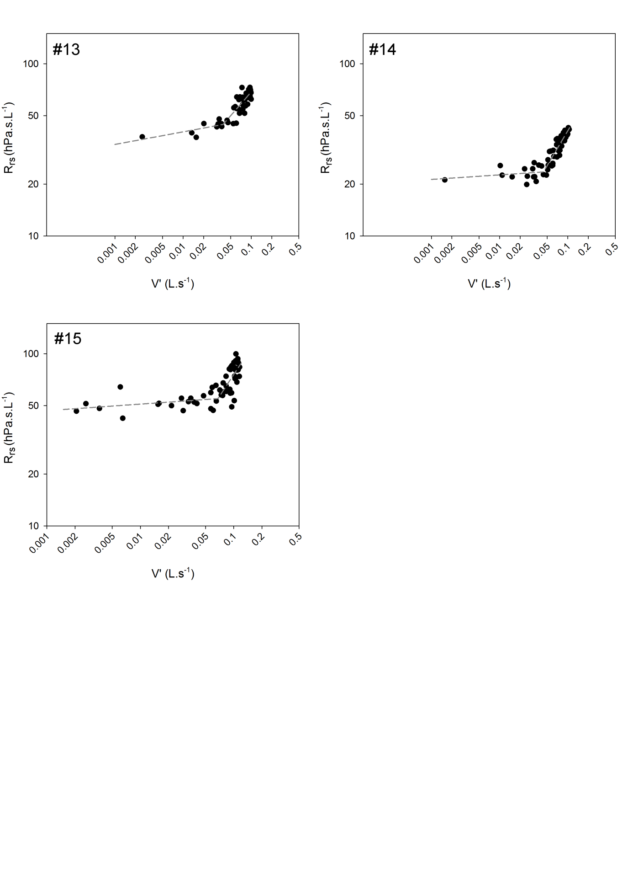

**Figure S4.** The effect of the geometrical correction on end-expiratory and end-inspiratory resistance (ReE and ReI, respectively), and the difference between ReE and ReI (ΔR) in healthy newborns (n=15). ΔR values are more realistic after correction, indicating less masking effect of the dynamic nonlinearities arising in the upper airways.

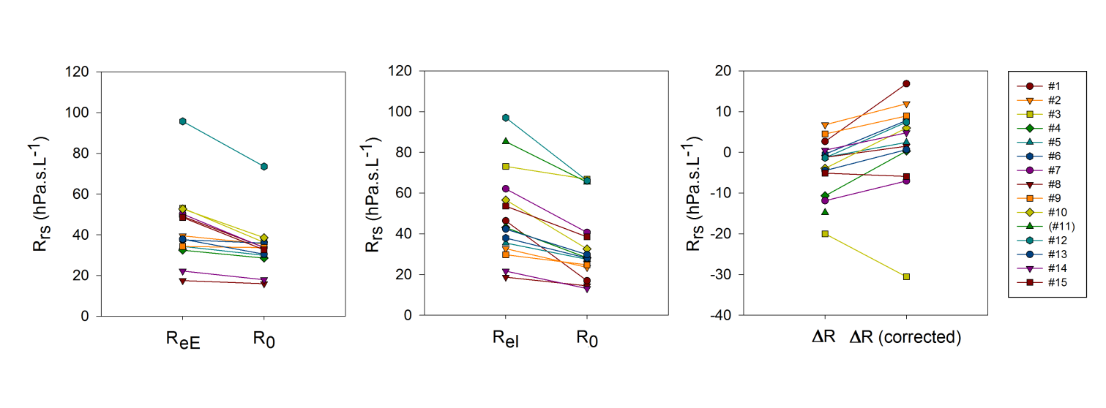

**Figure S5**. Relationship between the ratio of (measured) lowest oscillatory nasal resistance at 16 Hz (R0) and calculated Poiseuille R (RP) versus calculated Womersley number (Wo) of the casts without superimposed breathing. Each symbol represents a cast (n=45). Note the logarithmic scales. R0 values are typically 10-30 times higher than RP.

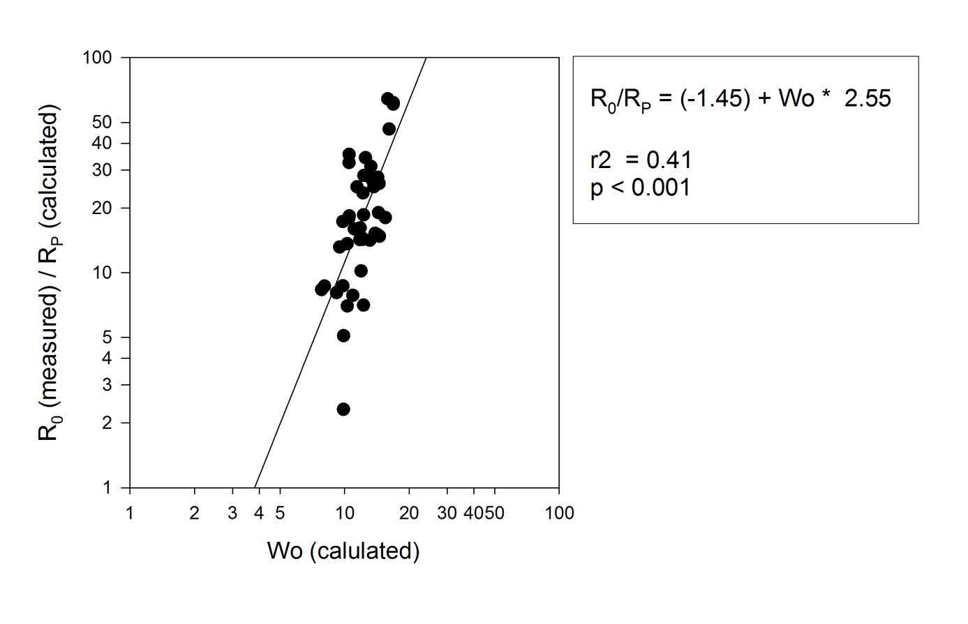

**Figure S6**. Nasal resistance (Rn) and reactance (Xn) versus flow (V’) in randomly selected upper airway casts. Different colours indicate different respiratory rate and/or tidal volume (VT) of simulated breathing pattern. Lowest oscillatory R (R0) and X (X0) are labelled with closed and open symbols, respectively. Note the marked V’-dependent increase in Rn and the „mirroring” course of Xn.

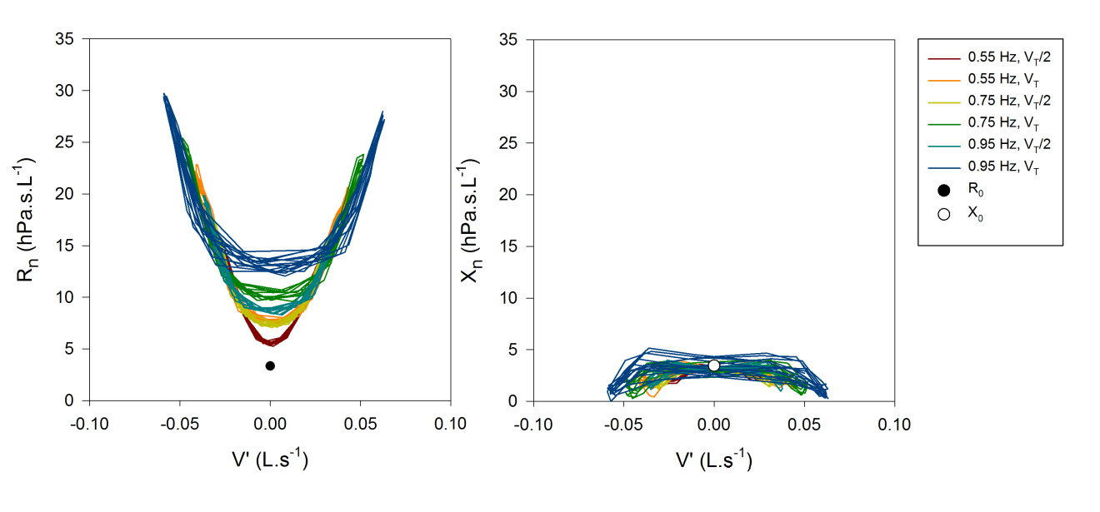

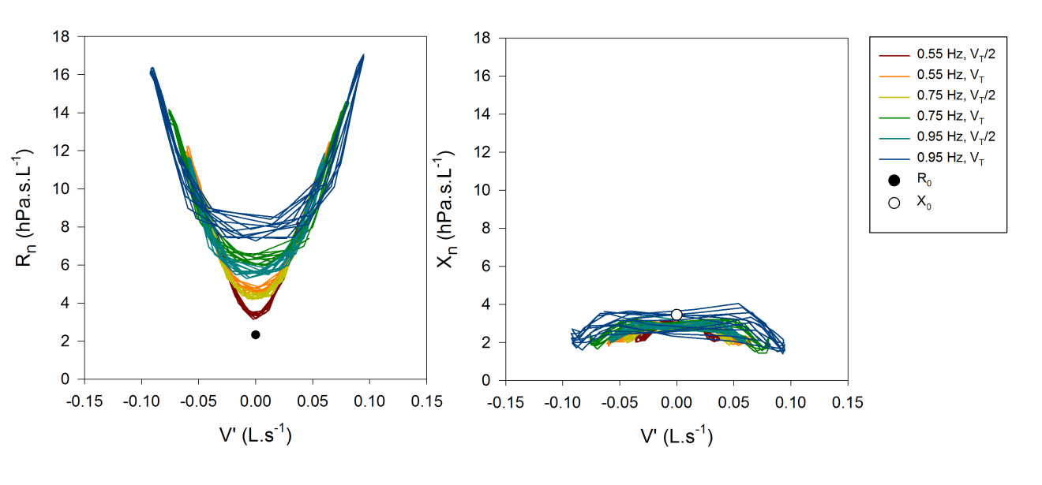

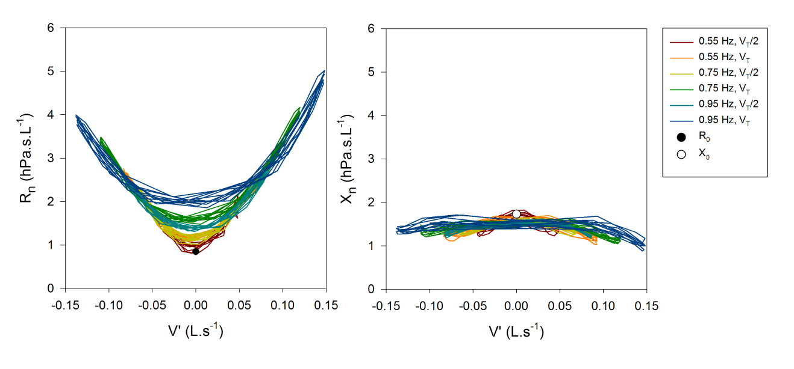

Figure S6 Continued

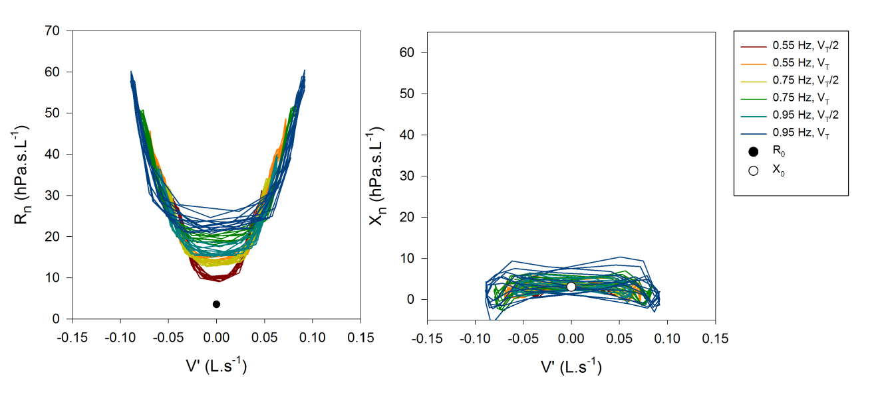

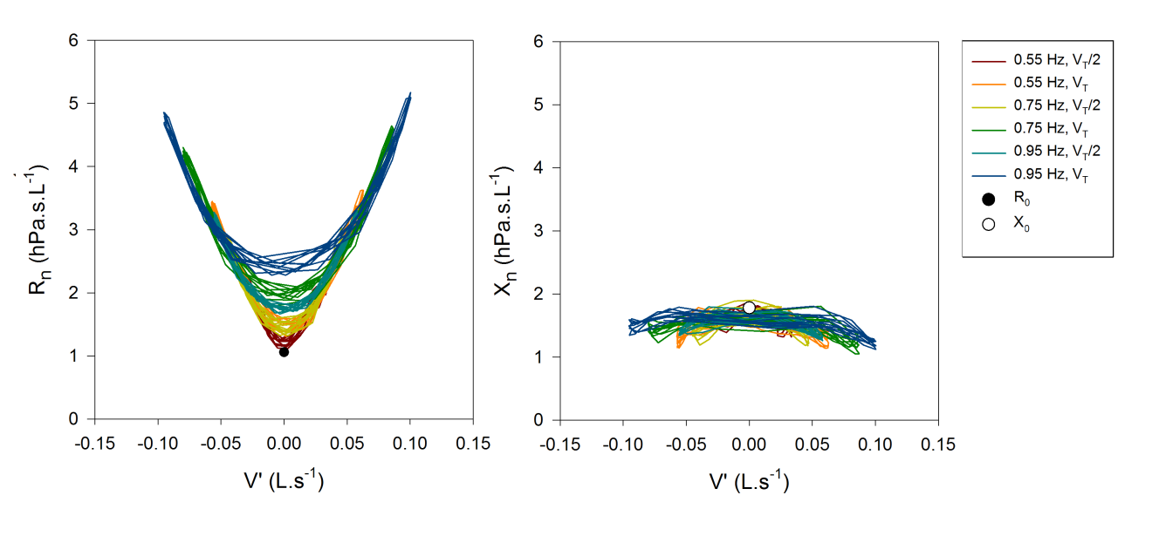

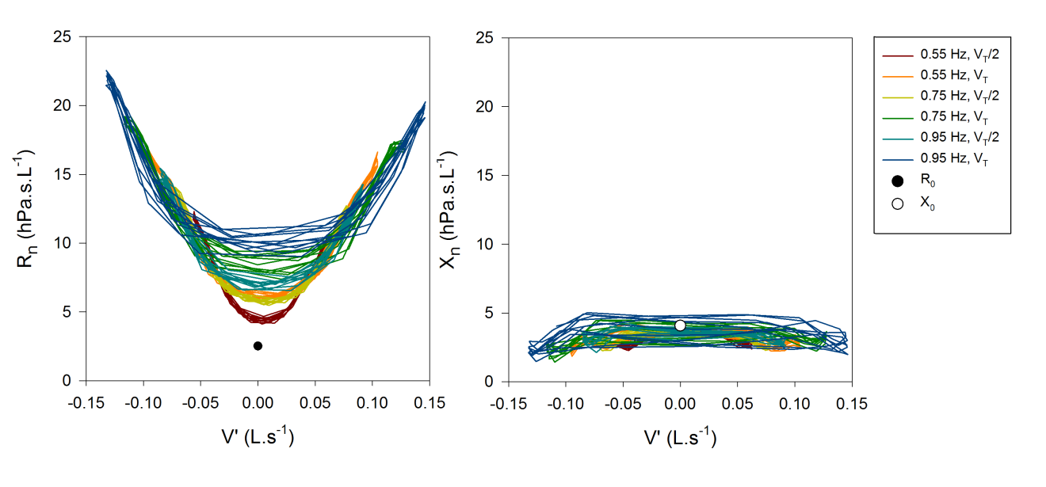

Figure S6 Continued

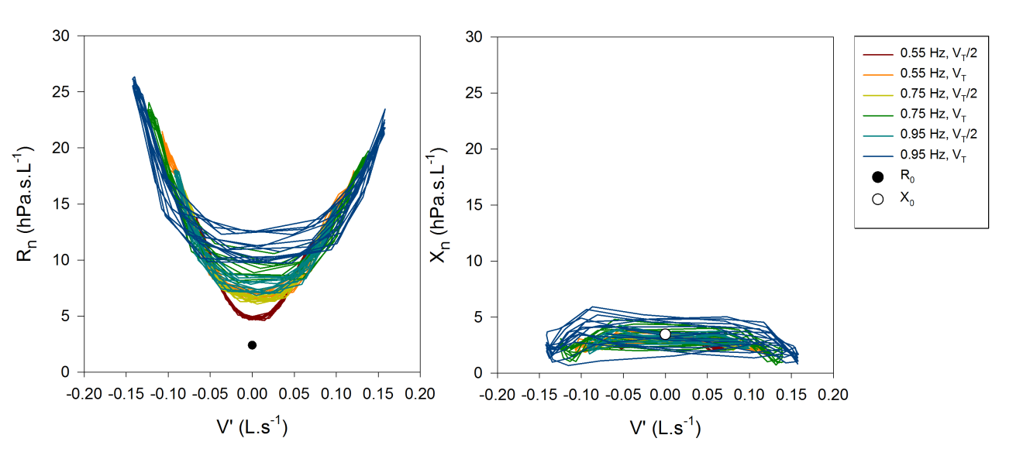

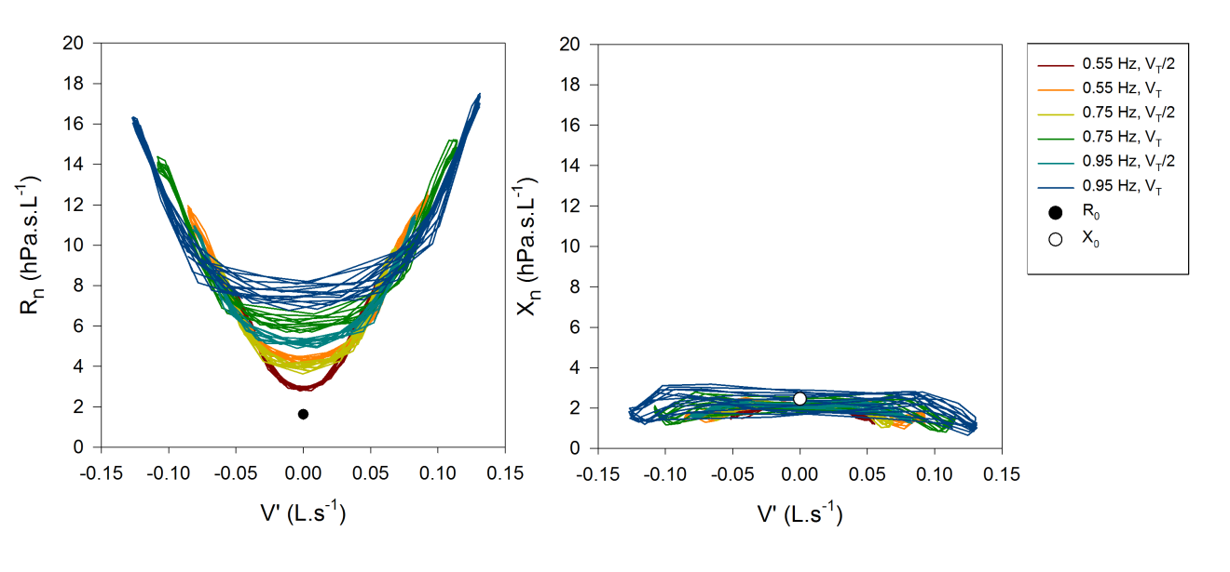

**Figure S7**. Box plots showing dynamic changes in nasal reactance (Xn) values. Xn measured at baseline conditions (X0) decreased significantly (p<0.05) when simulated breathing was applied. Xn measured at end-expirations (XeE) had lower values than X0, showing some effect of volume accelaration (V”) on Xn. Lowest values of Xn occured at expiratory peak flows (XV’maxE). Respiratory rate was set between 0.55 Hz to 0.95 Hz with halved tidal volumes (VT/2 – first table) or full VT (second table). Tables show the q values of pairwise statistical comparison (Repeated ANOVA on Ranks with Tukey post hoc test). Numbers in bold represents a significant (p<0.05) difference.

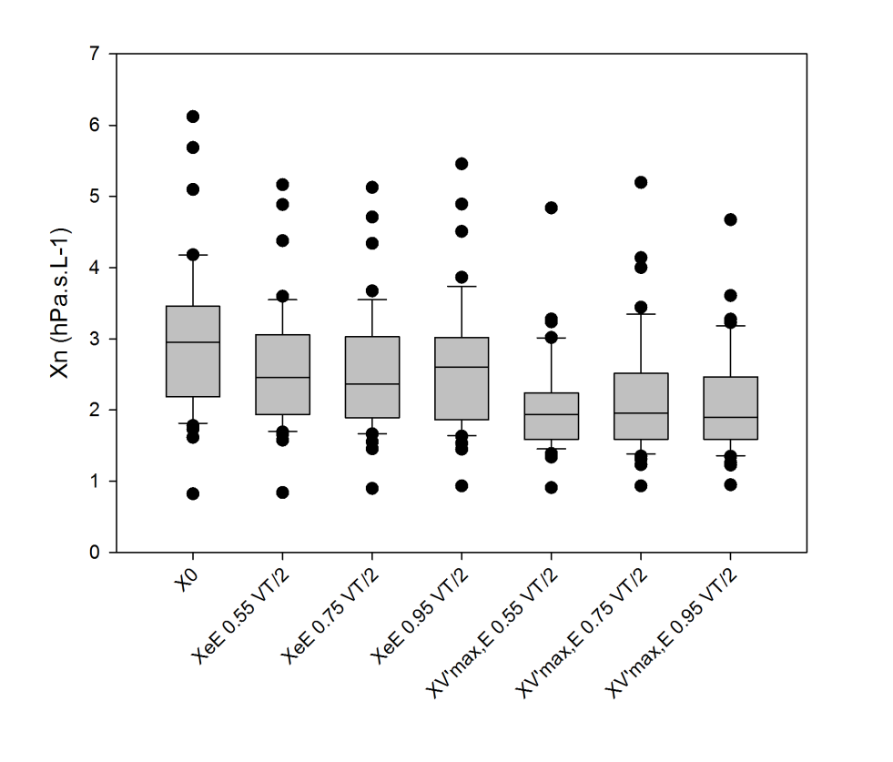

|  |  |  |  |  |  |  |  |  |
| --- | --- | --- | --- | --- | --- | --- | --- | --- |
|  |  | X0 | XeE | XeE | XeE | XV’maxE | XV’maxE | XV’maxE |
|  | q-values | (0.55 Hz, VT/2) | (0.75 Hz, VT/2) | (0.95 Hz, VT/2) | (0.55 Hz, VT/2) | (0.75 Hz, VT/2) | (0.95 Hz, VT/2) |
| X0 | |  | **4.55** | **7.77** | **5.78** | **14.836** | **13.318** | **14.353** |
|  | XeE | (0.55 Hz, VT/2) |  | 3.105 | 1.104 | **10.282** | **8.76** | **9.799** |
|  |  | XeE | (0.75 Hz, VT/2) |  | 1.99 | **7.18** | **5.659** | **6.694** |
|  |  |  | XeE | (0.95 Hz, VT/2) |  | **9.178** | **7.66** | **8.695** |
|  |  |  |  | XV’maxE | (0.55 Hz, VT/2) |  | 1.518 | 0.483 |
|  |  |  |  |  | XV’maxE | (0.75 Hz, VT/2) |  | 1.035 |
|  |  |  |  |  |  | XV’maxE | (0.95 Hz, VT/2) |  |

Figure S7 continued

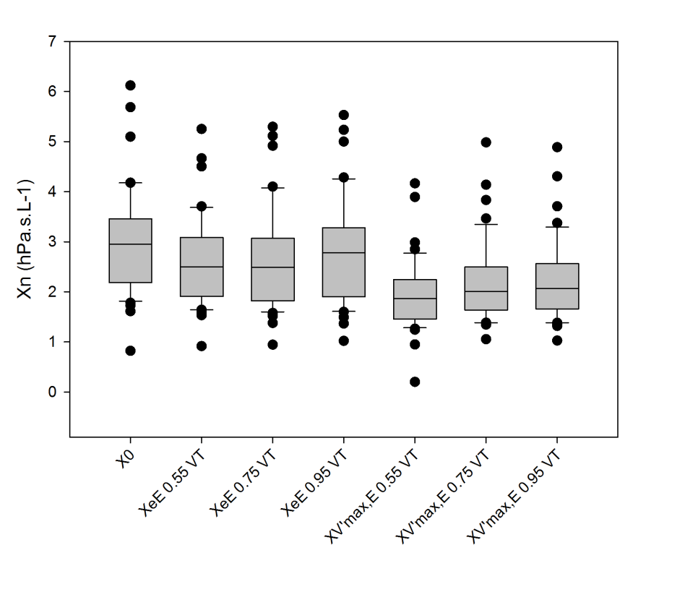

|  |  |  |  |  |  |  |  |  |
| --- | --- | --- | --- | --- | --- | --- | --- | --- |
|  |  | X0 | XeE | XeE | XeE | XV’maxE | XV’maxE | XV’maxE |
|  | q-values | (0.55 Hz, VT) | (0.75 Hz, VT) | (0.95 Hz, VT) | (0.55 Hz, VT) | (0.75 Hz, VT) | (0.95 Hz, VT) |
| X0 | |  | **6.28** | **7.798** | 3.795 | **15.043** | **12.835** | **12.214** |
|  | XeE | (0.55 Hz, VT) |  | 1.518 | 2.484 | **8.764** | **6.56** | **5.935** |
|  |  | XeE | (0.75 Hz, VT) |  | 4.002 | **7.25** | **5.037** | **4.416** |
|  |  |  | XeE | (0.95 Hz, VT) |  | **11.248** | **9.04** | **8.419** |
|  |  |  |  | XV’maxE | (0.55 Hz, VT) |  | 2.208 | 2.829 |
|  |  |  |  |  | XV’maxE | (0.75 Hz, VT) |  | 0.621 |
|  |  |  |  |  |  | XV’maxE | (0.95 Hz, VT) |  |

**Figure S8**. Respiratory system resistance (Rrs) and reactance (Xrs) vs flow (V’) graphs from in vivo measurements in newborns. Note that, in most cases, the mean value of Xrs is negative and Xrs "mirrors” the changes in Rrs.

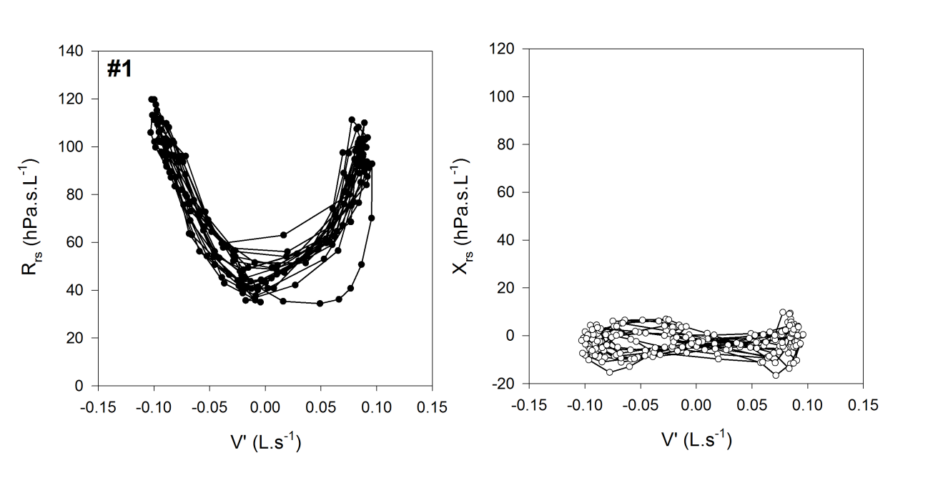

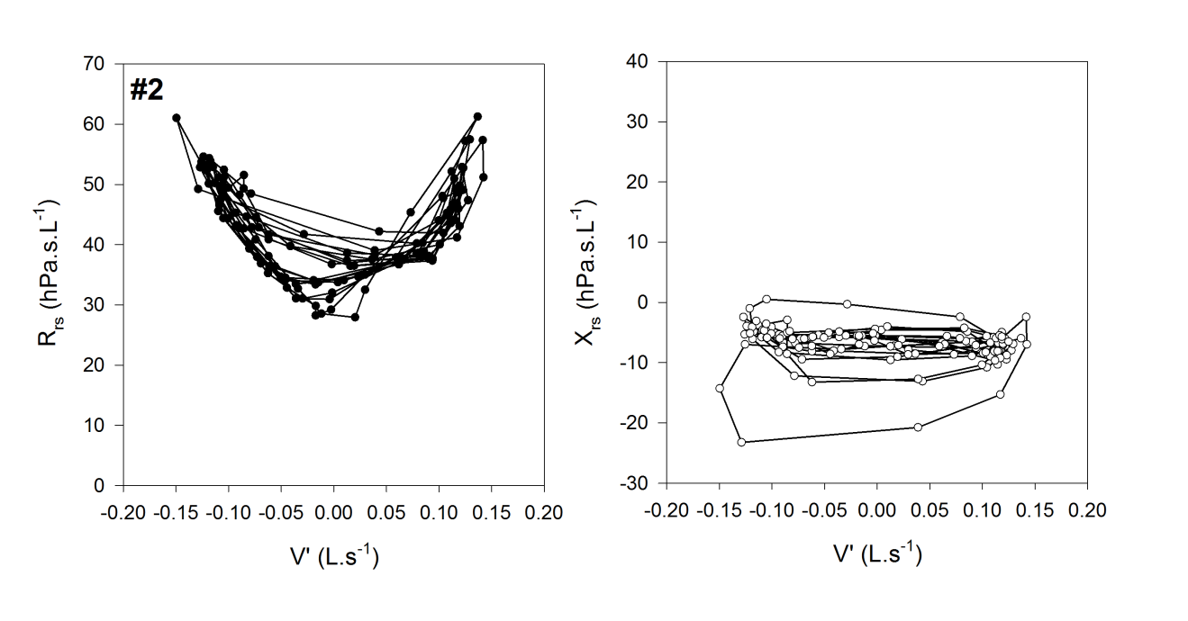

Figure S8 Continued

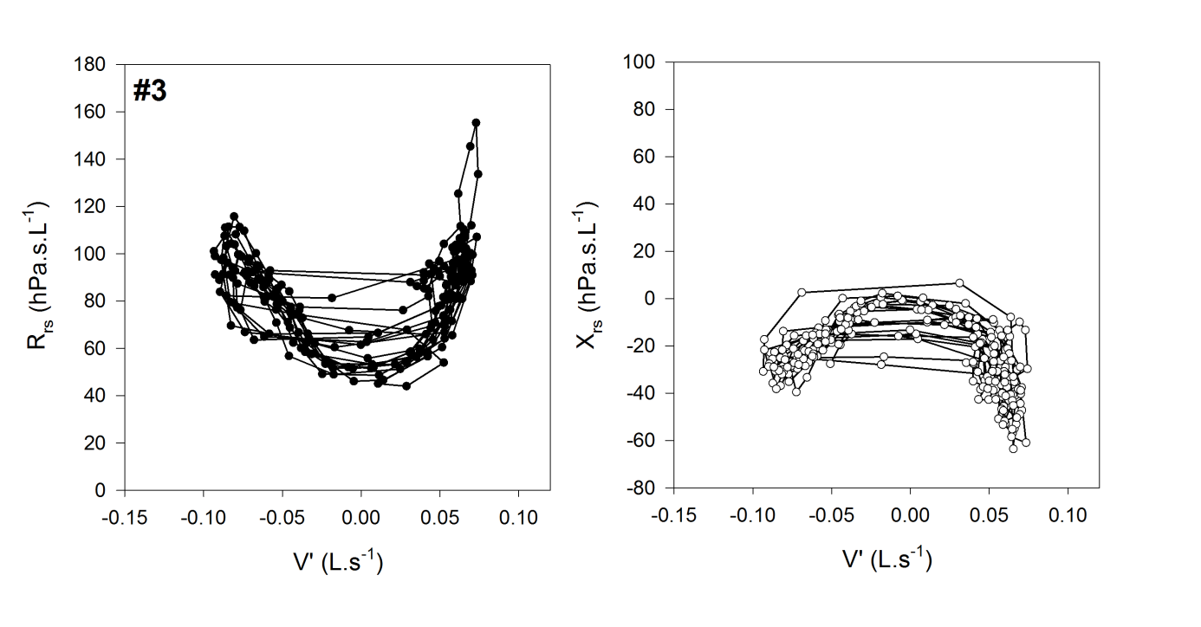

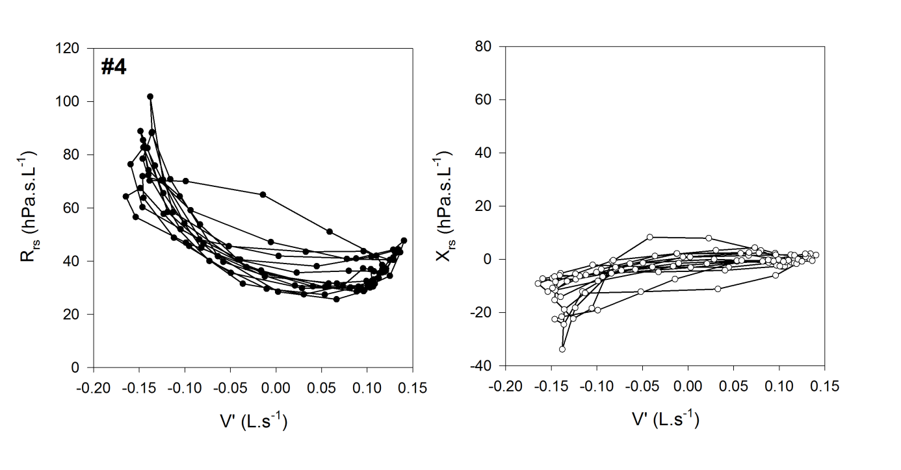

Figure S8 Continued

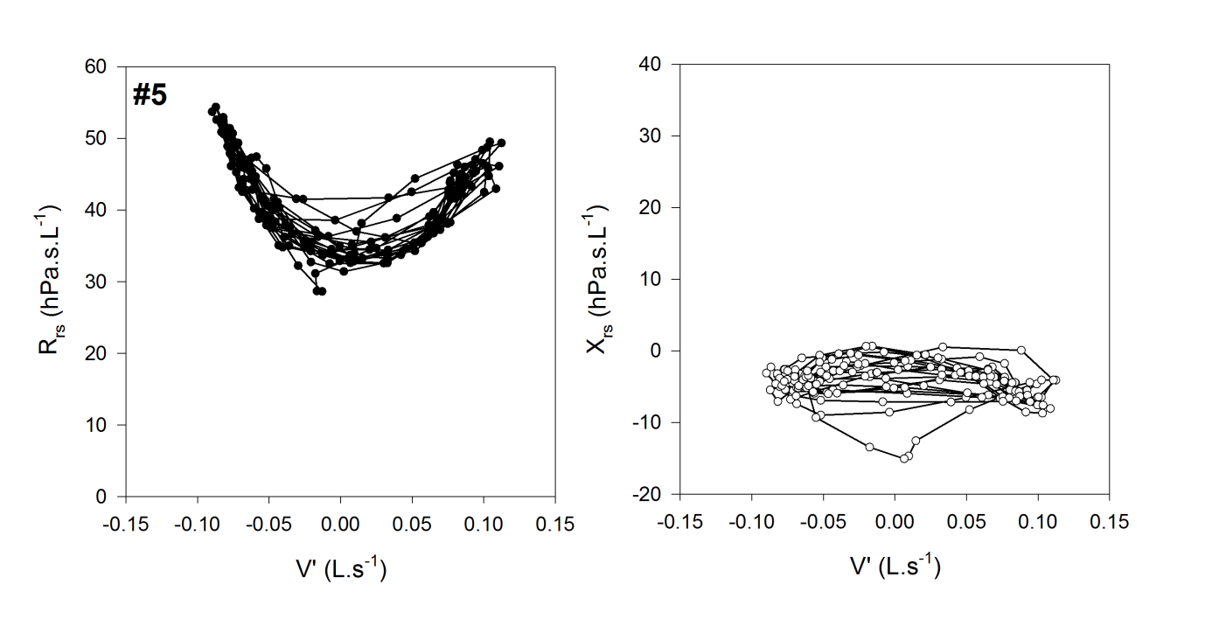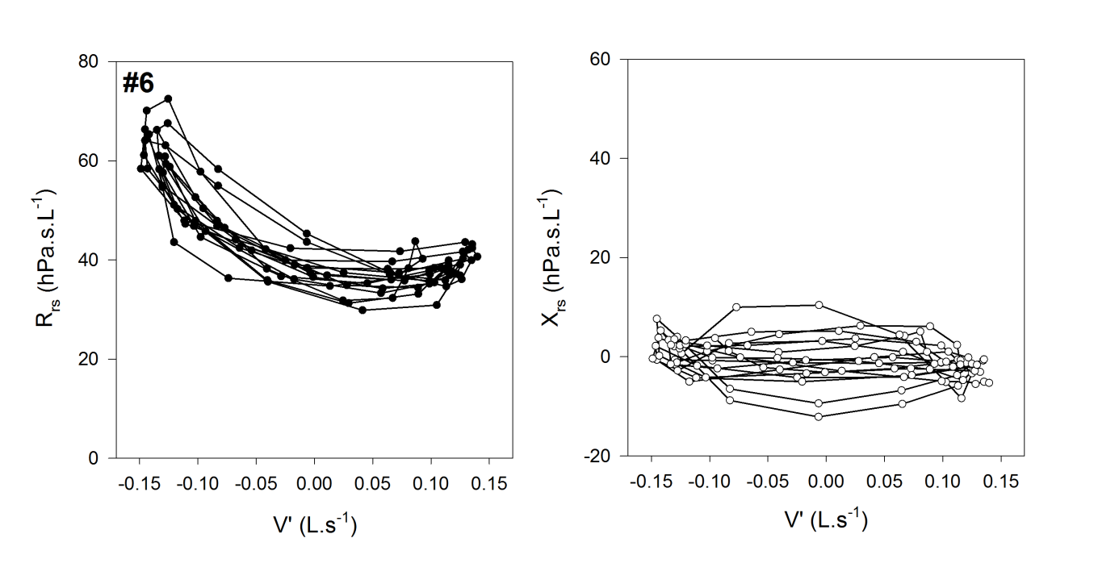

Figure S8 Continued

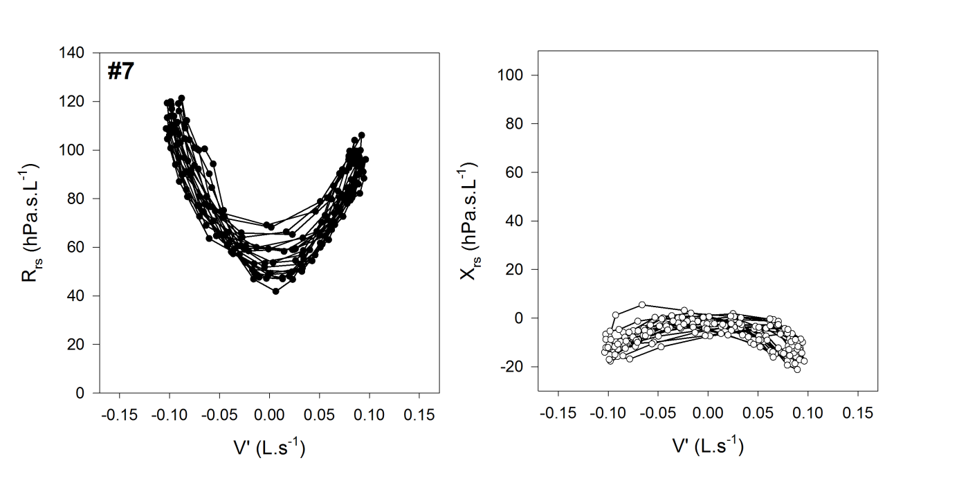

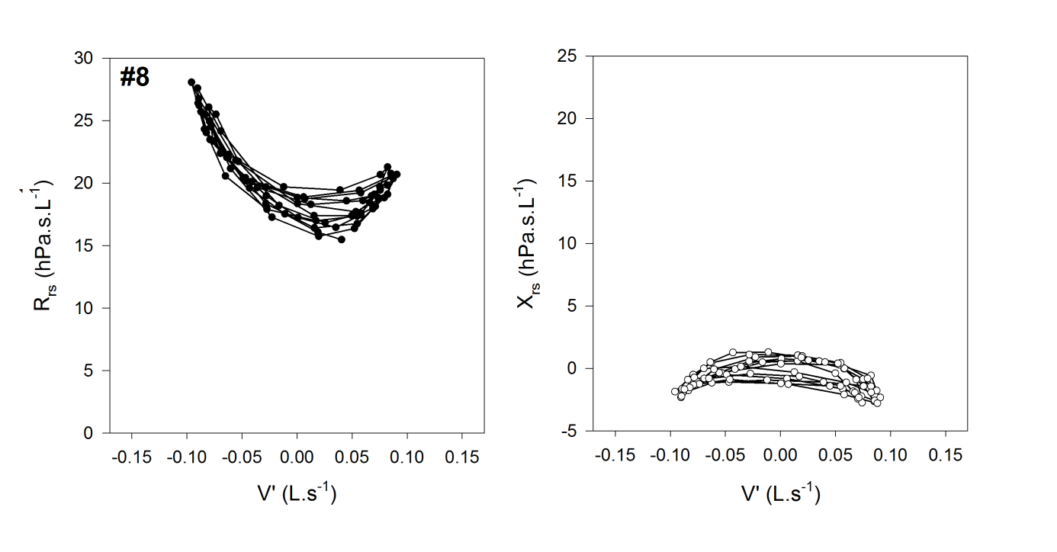

Figure S8 Continued

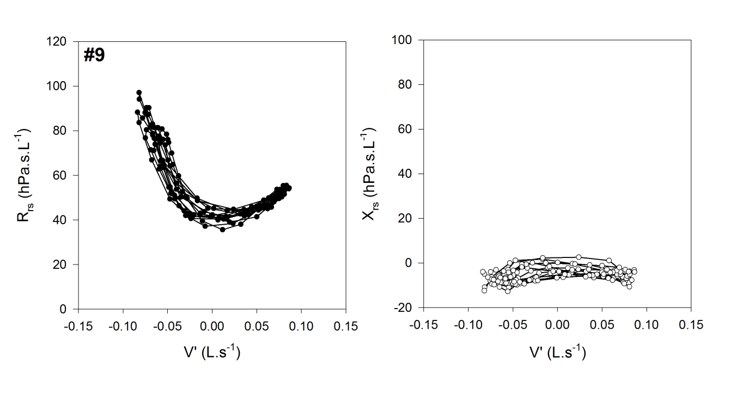

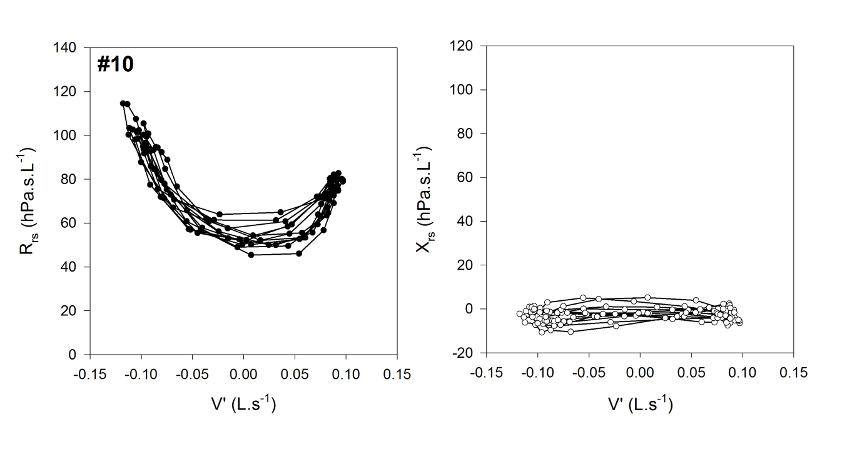

Figure S8 Continued

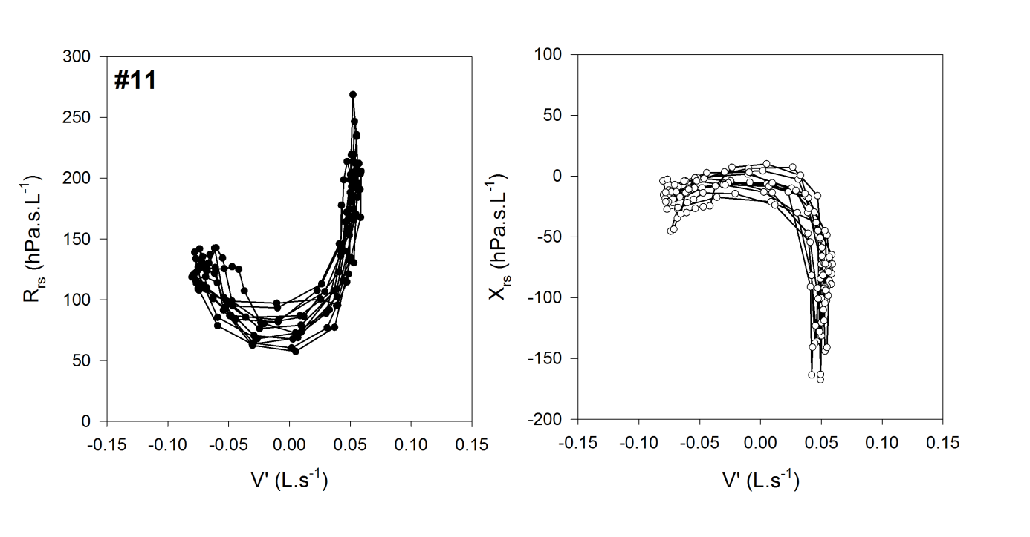

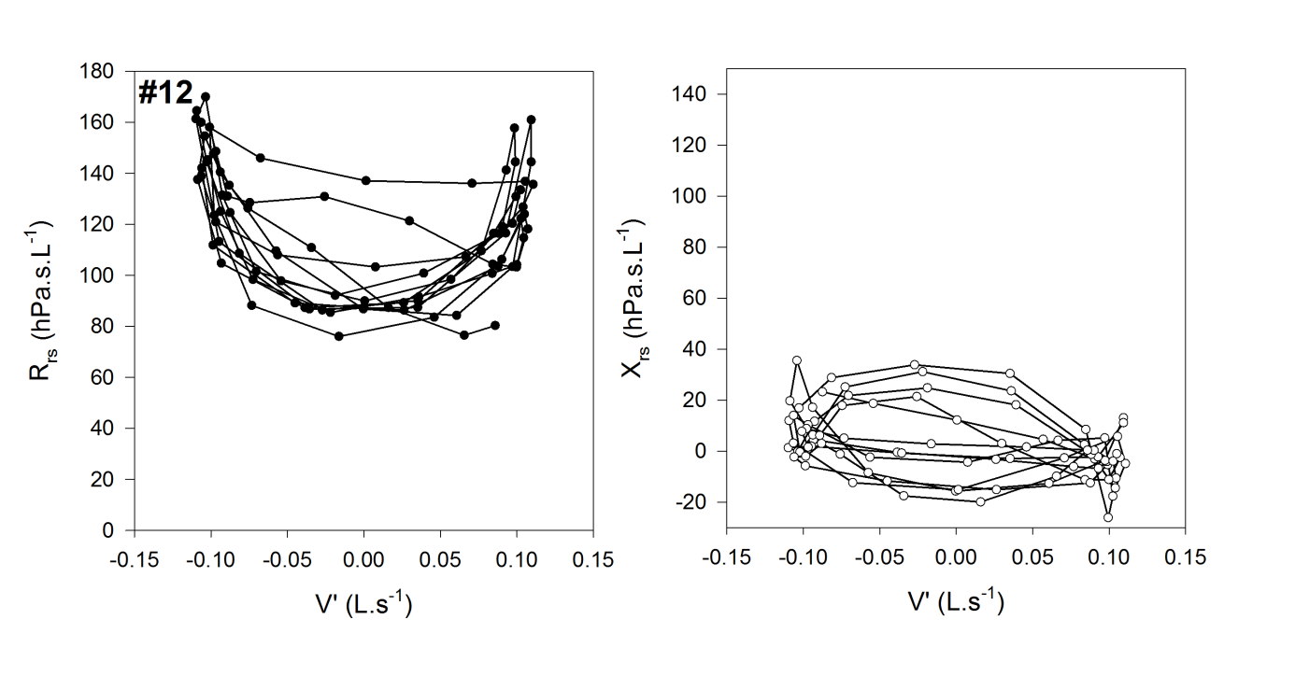

Figure S8 Continued

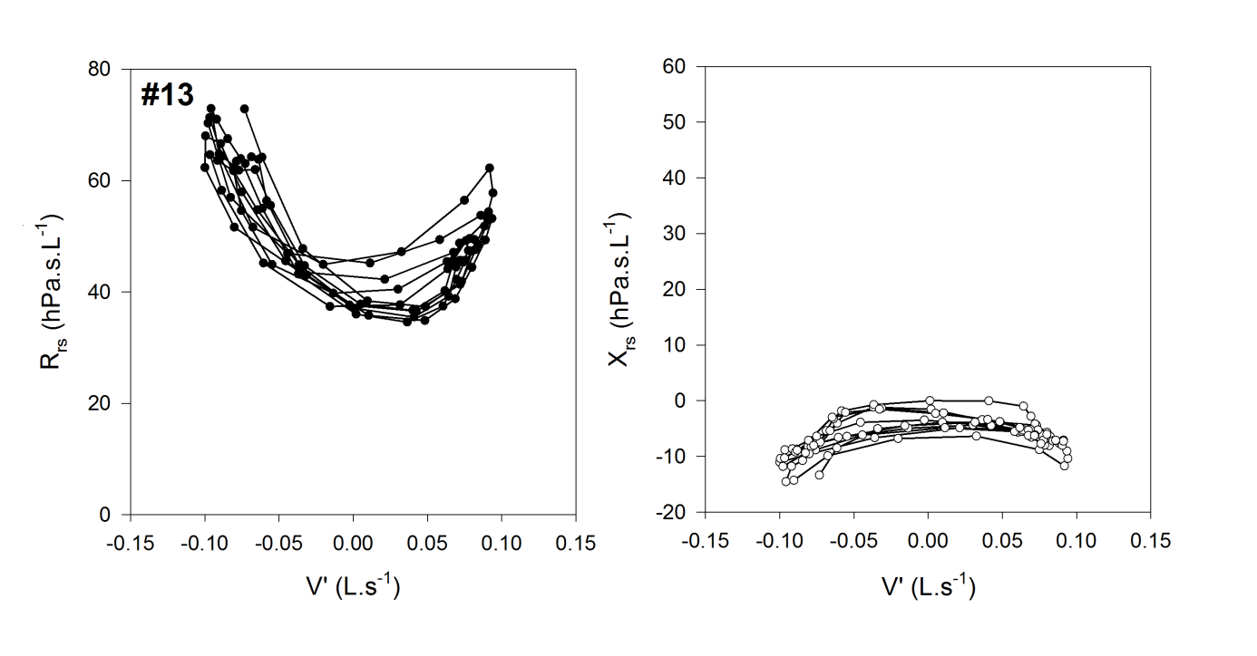

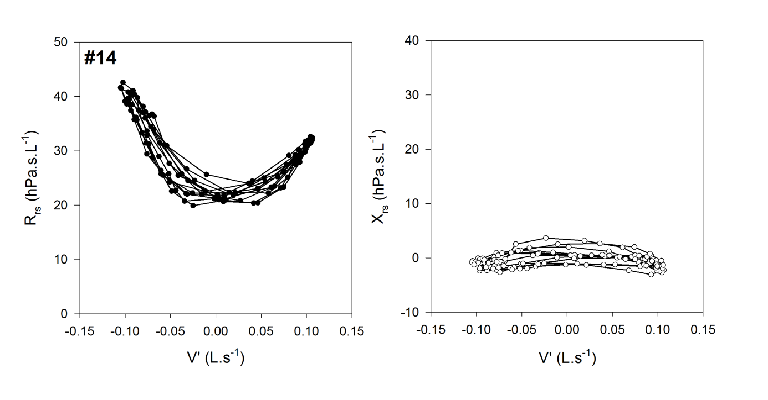

Figure S8 Continued

